LAB 1 (02/05/25)

Assignment-1.
Code:
public class Student{
private String studentName;
private String collegeName;
private int studentID;

public static void main(String[] args){
System.out.println("Successful");
}
}

Output:
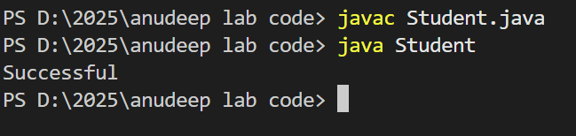

ASSIGNMENT 2
Code:
int age = 35.5; (incompatible type error)

public class Employee{

protected int id;
protected int age;
protected String name;
protected boolean isPermanent;
public static void main(String[] args) {

Employee emp = new Employee();
emp.age = (int) 35.5;

System.out.println("Successfully started");
}

}

output:
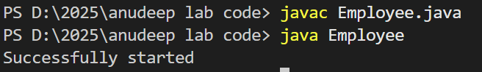
ASSIGNMENT 3;
Code:
public class Person {

String name = "John Doe";
int age = 30;
int salary = 50000;

public static void main(String[] args) {
System.out.println("Test Successful");
}
}
Output:
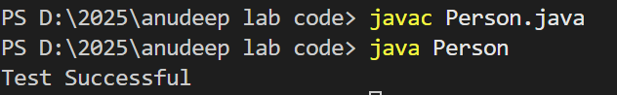

ASSIGNMENT 4
Code:
public class Rectangle {

double width;
double height;

enum Color {
RED, GREEN, BLUE
}

Color boxColor;

public static void main(String[] args) {
System.out.println(Color.BLUE);
}
}

Output:
